APS Survey Results - Akron Power Squadron - Name Change

The following two-question survey was posted on the internet site “Survey Monkey” on Nov 13, 2009, and the responses summarized Jan 1, 2010. In addition to an article in December’s Scuttlebutt, two mass e-mails were sent as reminders – one on Dec 6 and a follow-up around Dec 18.

There were 53 responses, with 25 members adding comments.

1. Please rate your Preference for Changing the name of "Akron Power Squadron" to "Akron Sail and Power Squadron"

Strong "Yes" 37.7% 20 votes
"Yes" 32.1% 17 votes
Neutral 7.5% 4 votes
"No" 9.4% 5 votes
Strong "No" 13.2% 7 votes

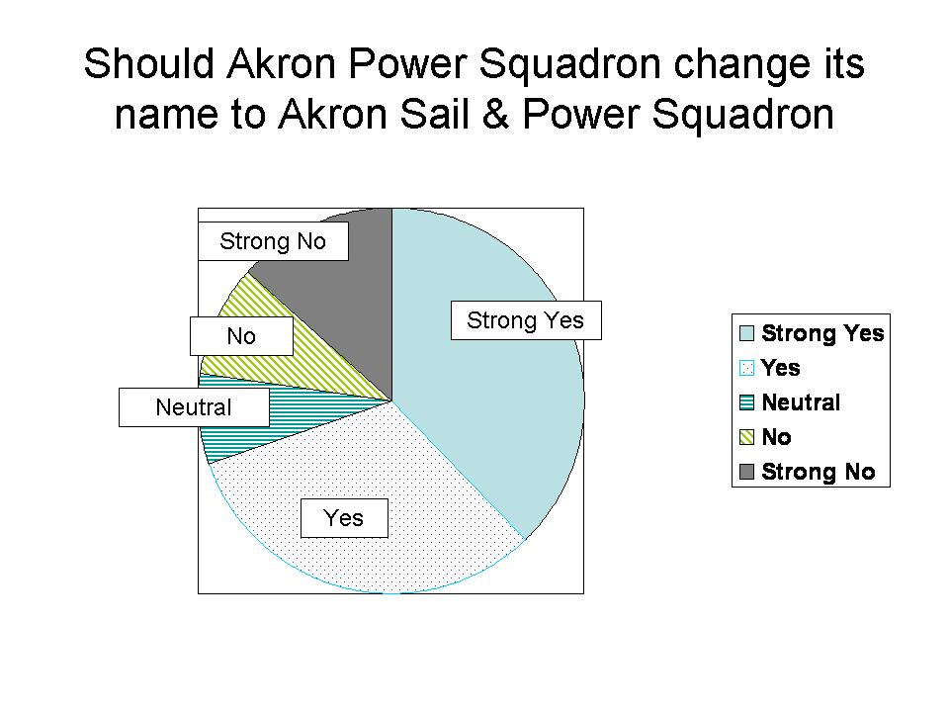

2. Please give any additional comments, if you would like to do so.

Comments by members who responded STRONG "YES" (twelve comments)

- The "Sail" name, along with "Power", connotes "boating" to me. In addition, sailors would see it was a group that included them. Also, we would be the first in D7 - APS (or should I say, ASPS) has always been a leader !
- It just makes total sense!
- As a sailing member of the squadron, and based upon comments and questions from sailing friends, I feel certain it will lead to growth of the Akron Power Squadron and include many sailing acquaintances.
- I feel the name "Power Squadron" implies exclusion of sailors. I would even like Akron Yacht Squadron better
- I find it difficult to come up with a reason not to do it. It may not help, but it won't hurt to be more inclusive and have a name that the Public understands.
- I'm biased, as I made the proposal some time back, and this survey may well be a result of that effort.
- Would prefer Akron Power and Sail Squadron
- It certainly will represent the fact as well as the spirit of our organization. With this name it becomes also clear that we are also an association of sailors.
- We have lots of sailing members
- Since we own a sailboat we would now feel more part of "the group"! Also USPS needs to make the change also so as not to be confused any longer with the United States Postal Service, Thanks for asking for our opinion.
- This is a more appealing and representative message
- “Akron Sail and Power Squadron” reflects much better the membership and purpose of the organization. The power boaters may not like "Sail" being listed first, but it flows better that way. If that's a sticking point, then go with "Power and Sail," but make it sound like a boating organization, not a group of people who like power tools!

Comments by members who responded "YES" (eight comments)

- It may be a pain to change the name across the board, but if it could improve membership and have sailors feel more welcome, great!
- I feel that it would be nice although it is cumbersome. I do not feel that it is necessary to do so. I feel the original name has more public recognition.
- Whether we sail or go under power, we are all boaters. The Squadron has so much to offer for all types of boaters, so I feel it would be a good idea to change the name. It may or may not help to increase membership, but at least it makes the Squadron's door open to a wider variety of people.
- If it makes you "puffers" feel better, I'm all for it.
- If it is believed that the name change would bring new members, then I am all in favor, unfortunately, the above survey is not overwhelmingly supportive of a name change. Not that it makes a big difference. Is "Akron Boating Squadron" an option?
- I am for it if it helps to attract more members.
- I have no strong feelings either way. If it makes the sailors feel more included and/or it causes an increase in membership, then it would probably be a good move.
- Might as well. Once the sailors were allowed in the damage was done. Note, I can say this since I am a reformed former sailor.

Comments by members who were "NEUTRAL" (four comments)

- If things were to be alphabetical order, it would be: Akron Power and Sail Squadron. Then again maybe that's too many sss' in a row.
- I don’t really like the new proposed name
- It has been this way a long time. We have a good number of sailors. If a large majority says change or is neutral, then perhaps change it. If the numbers aren't there, don't change it.
- My wife and I have been members for a few years, but inactive. I think the biggest problem is the same thing that is hitting every hobby or sport - the economy. I do not see anyone reporting a negative result. My only concern would be the admin involved in a name change. Good luck in whatever is decided.

Comments by members who responded "NO" (one comment)

- This has been going on for almost 10 years and the Squadron did not elect to make the name change and after reading all the surveys from around the country and all the wasted effort why don’t we give it rest!

There were no comments by members who responded "STRONG NO"

